Milestone #2
Jack Morris

Overview

URL: https://it3203fall21jmorr123.azurewebsites.net/

I remade my CARIT site using flex instead of using float. All of the pages are very slightly different but basically still remains the same. My files are named appropriately, I have an external javascript file that I used. The css style file is listed under the student form page at the top. All the pages work on my hosted site and I didn’t copy any scripts or generate JavaScript from wizards. The new page has the same style and layout as the rest of the site, except I wanted to make the form stand out a little more but it’s just a 1 color difference that’s somewhat faded so it’s not “too much”. I have some color coding on form controls, as well as some disabled selected value options for my select tag. There is a bunch of visibility and display properties, placeholders, labels, legends, fieldset, and some required properties. On my form page, I linked my milestone1.css file called test.css and have a brief discription of the page, purpose, and instructions. The form gets larger upon selection of the student status and displays the expected classes. The user can then enter in their grades which will be checked in case they don’t enter in the correct letters and the results will be displayed outside of the form in a <div> which is how I understood the requirement. The letter grades are converted to numeric points which is shown in the average variable in the results. If the user doesn’t meet the requirement there are different messages that are shown.

Description of screenshots:
IMAGE 1

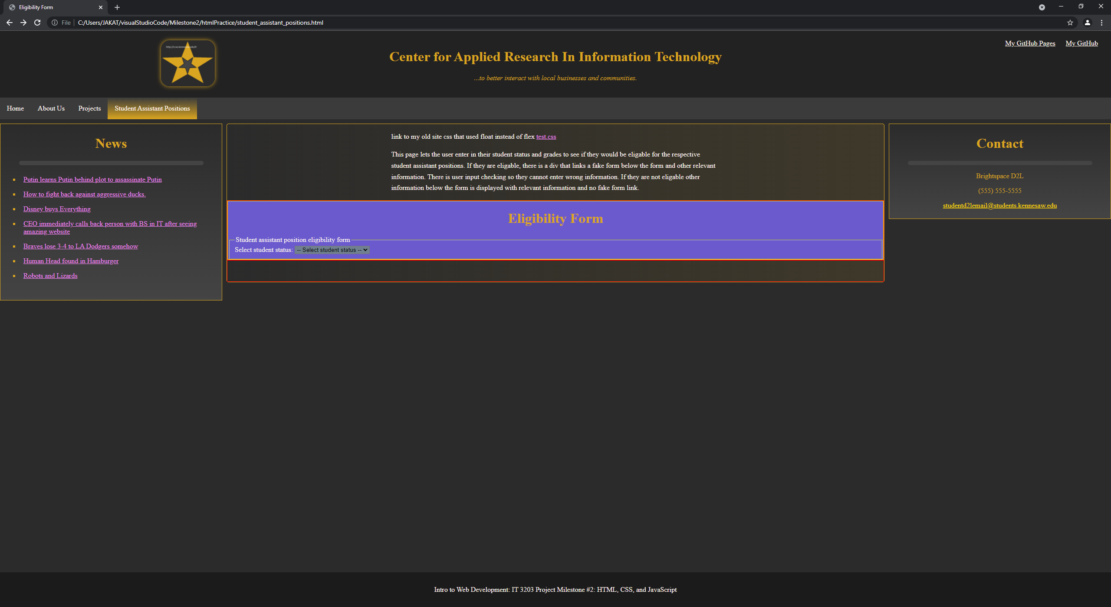
IMAGE1: Hereis my form page, The form look small because I haven’t selected anything yet, it grows in size the more you interact with it. You can also see the description of the page, the purpose, and instructions. I also have a link to my old css file.

IMAGE #2 AND #3

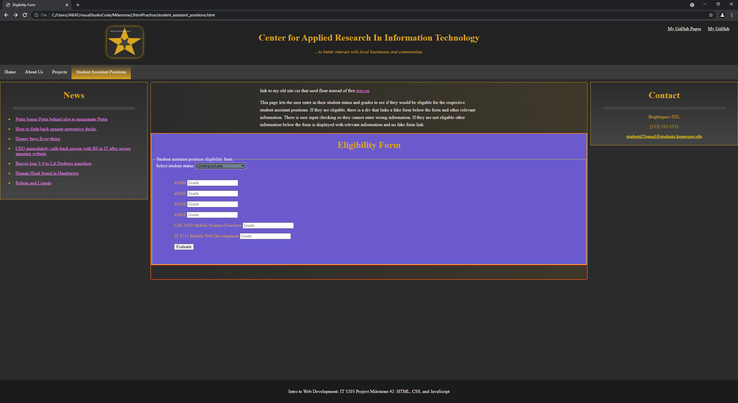

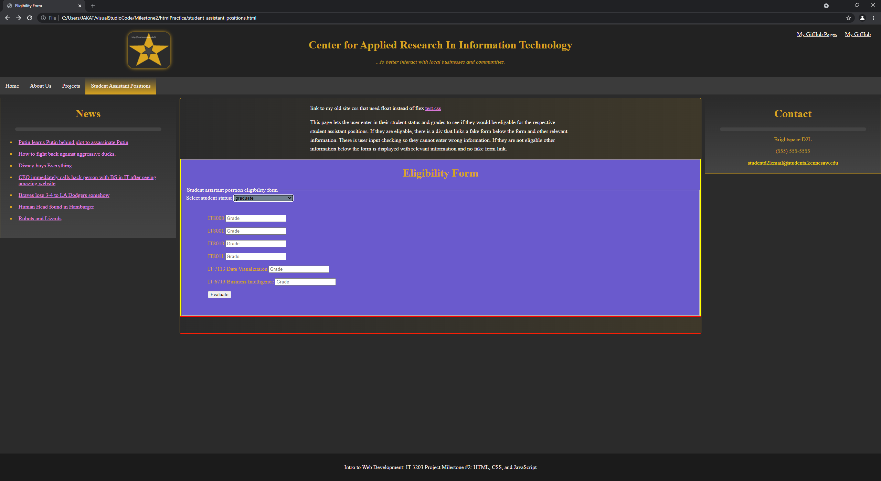
IMAGE #2 AND #3: Here you can see that I have selected graduate or undergraduate, they both display different classes in a list depending on which was selected.

IMAGE #4

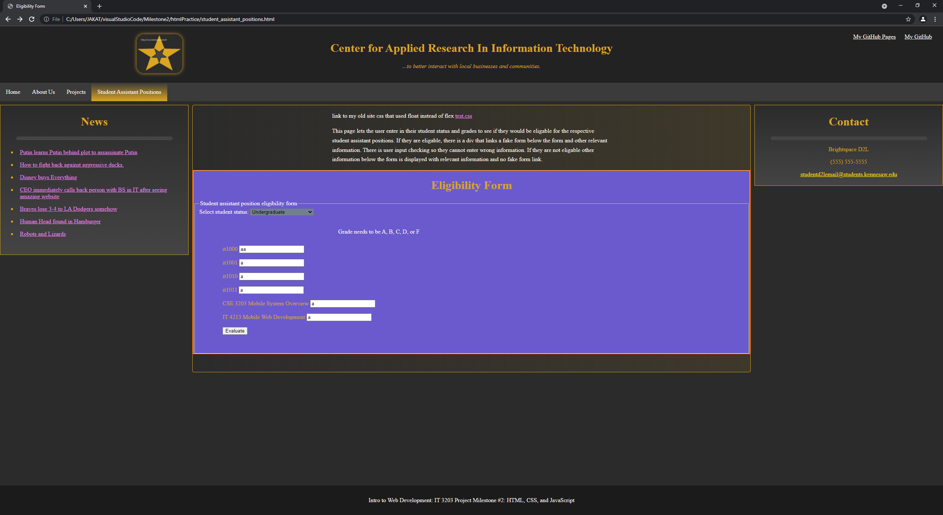
IMAGE #4: Here If I select a student status and enter in too many letters or a character that isn’t lower or upper case a,b,c,d,f then It gives a small little prompt saying that the grade needs to be a certain waay.

IMAGE #5

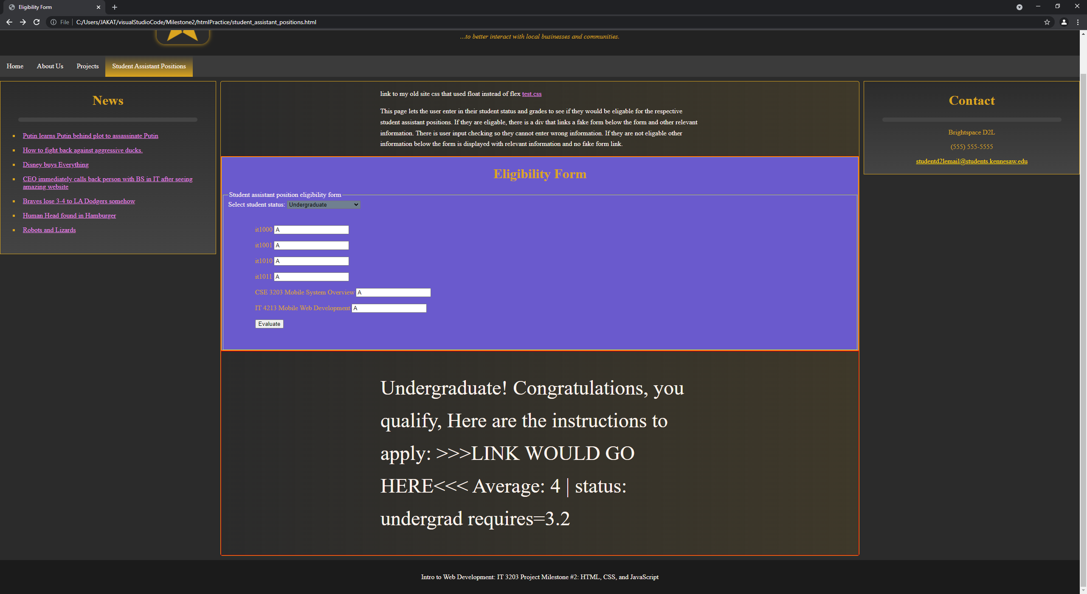

IMAGE #5: Here I have submitted my grades for the undergraduate status, you can see that the average is a number, given that its all A’s it isn’t a decimal, however this demonstrates that I have converted the letter grades to numeric points and put them into an average. There is also some additional information here.

IMAGE #5.5

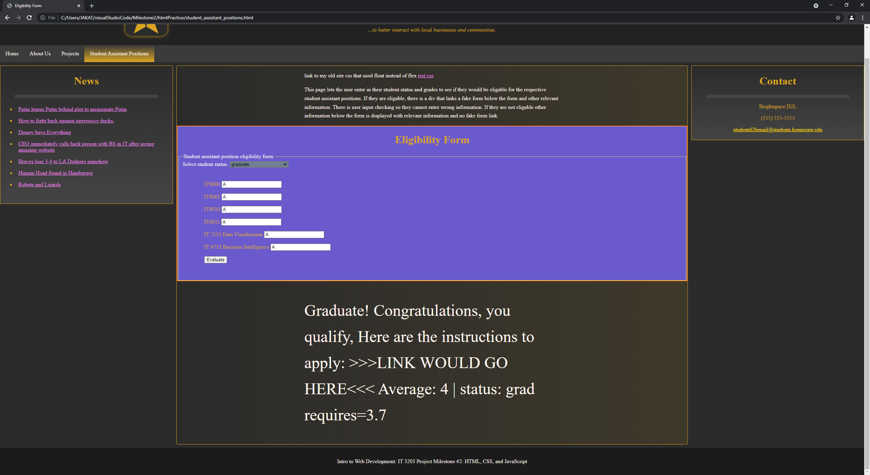

IMAGE #5.5: This is the same as #5 except it is for the graduate students.

IMAGE #6

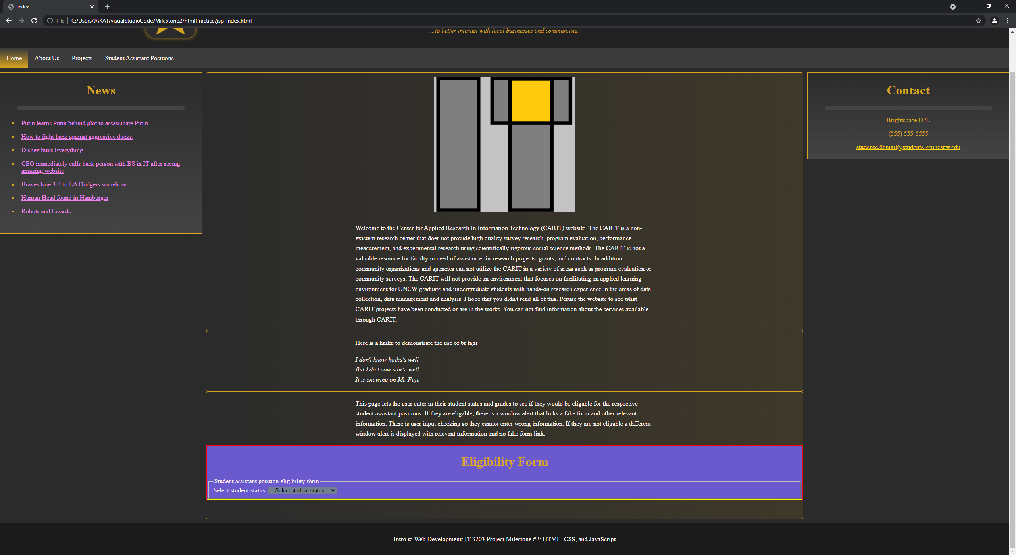
IMAGE #6: Here you can see the front page or the index where I understood one of the requirements was to have the form on the front page working as well. It works the same way here.

